Employment Resources

Table of Contents
Lesson 1: Overview of Competitive Integrated Employment 1
Lesson 2: Agencies, Programs, Resources and Services 1
Lesson 3: Service Coordinator Responsibilities 2
Resources for Veterans 2
Waivers, Bulletins, and Directives 3
DHS ListServs 3
Bulletin Search 4
Publications Search 5
DHS Form Search 6
Alternatives to Nursing Homes 7
Employment and Employment-Related Services Bulletin 8
Guidance on Conversations about Employment for OLTL Participants 13
Instructions for Completing the OVR Referral 16

Lesson 1: Overview of Competitive Integrated Employment
The Guidance on Conversations About Employment

Lesson 2: Agencies, Programs, Resources and Services
PA Department of Labor and Industry – PA Office of Vocational Rehabilitation (OVR)
www.dli.pa.gov/Individuals/Disability-Services/ovr/Pages/default.aspx
A copy of the Instructions for Completing the OVR Referral can be found at the end of this resources document.
PA Medical Assistance for Workers with Disabilities (MAWD)
www.dhs.pa.gov/Services/Assistance/Pages/MA-for-Disabled-Workers.aspx
Work Incentives Planning and Assistance (WIPA)
https://choosework.ssa.gov/about/meet-your-employment-team/#WIPA
PennDOT Public Transportation Services and Programs Map
https://gis.penndot.gov/transitmap/
PA ABLE
www.paable.gov/
PA Statewide Independent Living Council (PA SILC) Resources and Links
http://pasilc.org/resources-links/
PA Client Assistance Program (CAP)
www.equalemployment.org/
PA Link to Aging and Disability Resources
www.aging.pa.gov/local-resources/pa-link/Pages/default.aspx
PA CareerLink – Visit this site to find your local CareerLink as well as some of the services it provides.
www.pacareerlink.pa.gov/jponline/
Disability Rights Pennsylvania
www.disabilityrightspa.org/

Lesson 3: Service Coordinator Responsibilities
HCSIS Guidebook
www.hcsis.state.pa.us/hcsis-ssd/default.aspx
LMS Tip Sheet
www.hcsis.state.pa.us/HCSISLMS/custom/uploads/docs/LMS%20Tip%20Sheet.doc

Resources for Veterans
Bridge My Return – Translates core military skills and training to help Veterans and transitioning service members find employment.
https://www.bridgemyreturn.com/
U.S. Department of Veterans Affairs
1-800-MyVA411, (1-800-698-2411)

Waivers, Bulletins, and Directives

DHS ListServs
www.dhs.pa.gov/about/Pages/Listservs.aspx
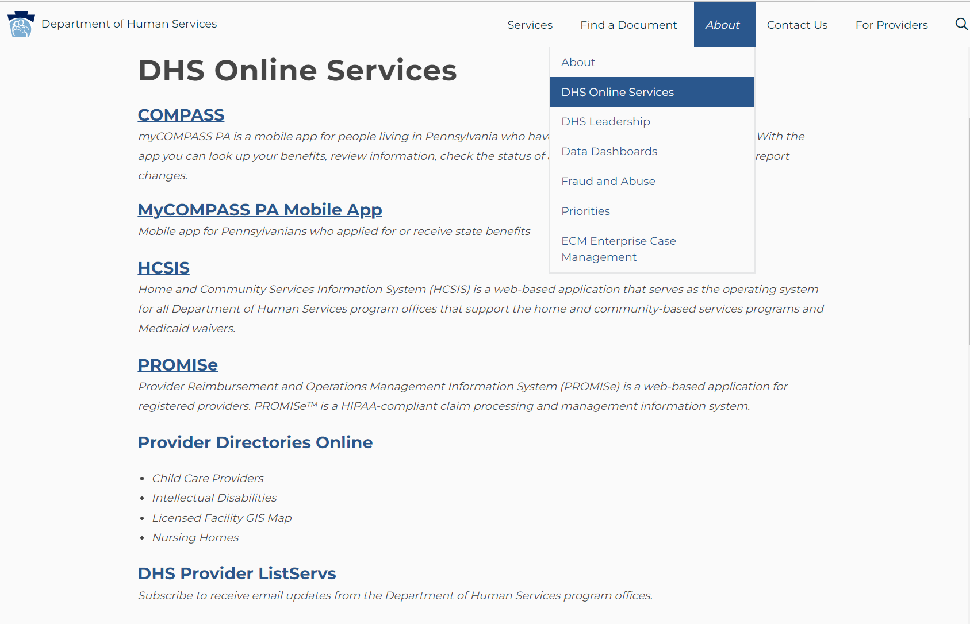
1
2
3

Bulletin Search
www.dhs.pa.gov/docs/For-Providers/Pages/Bulletin-Search.aspx
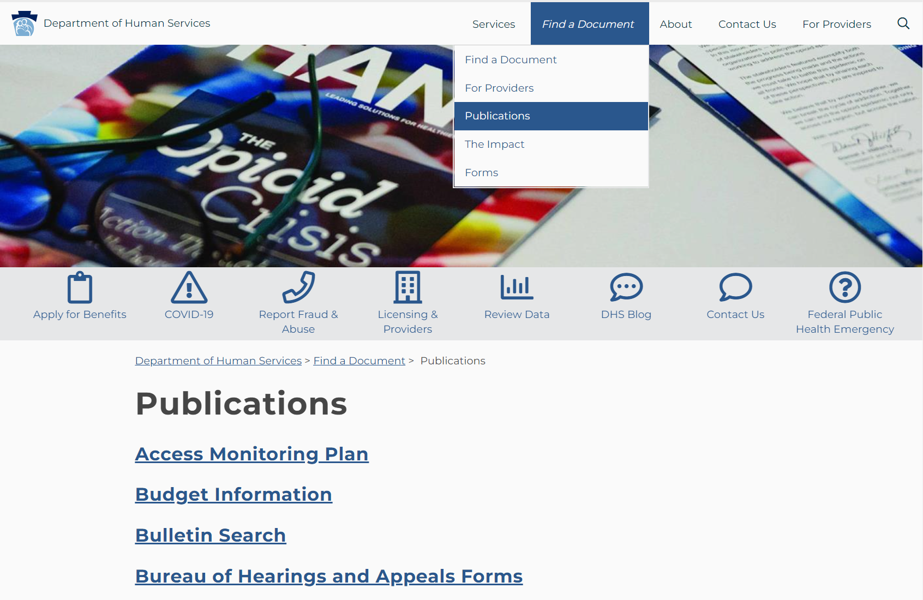
2
3
1
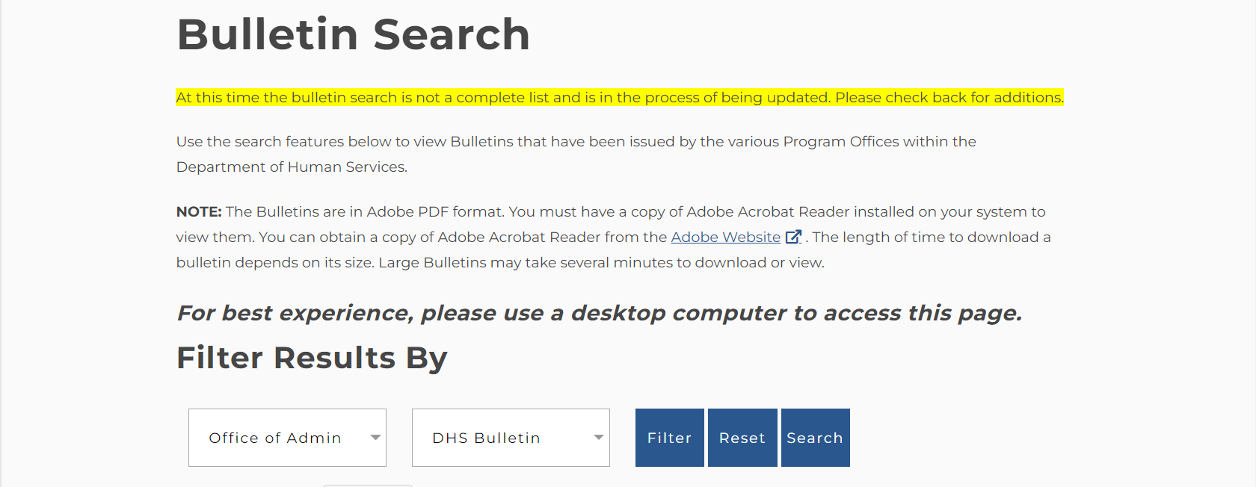

Publications Search
www.dhs.pa.gov/docs/Publications/Pages/default.aspx
2
1

DHS Form Search
www.dhs.pa.gov/docs/Publications/Pages/Form-Search.aspx
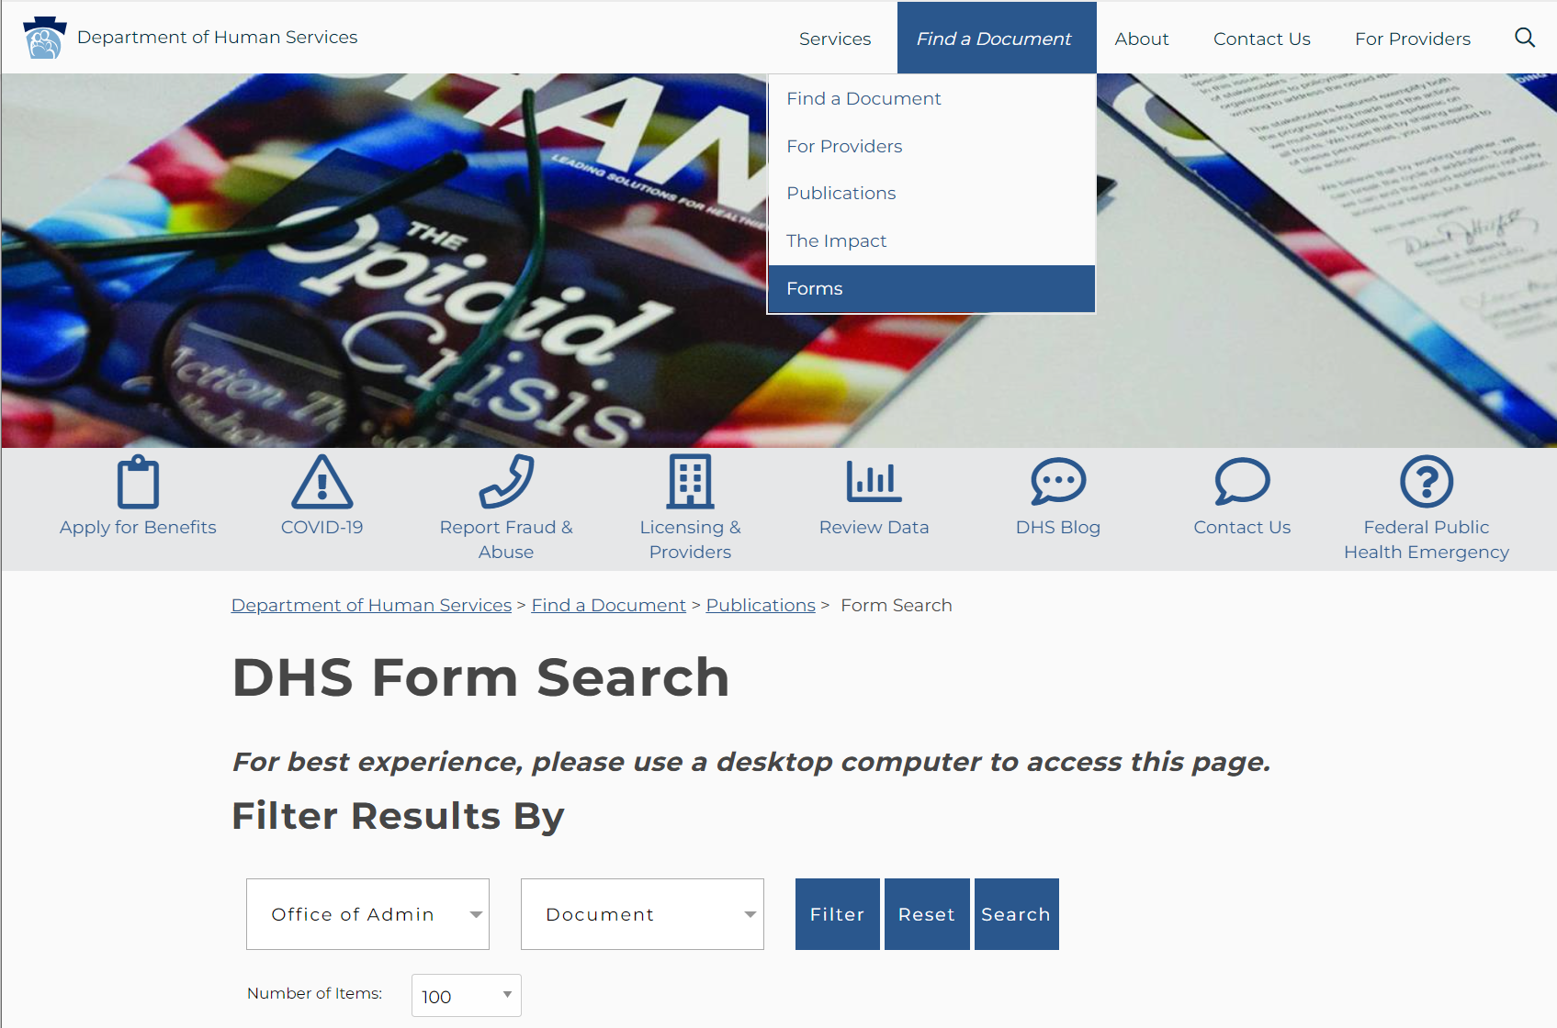
2
1

Alternatives to Nursing Homes
www.dhs.pa.gov/Services/Disabilities-Aging/Pages/Alternatives-to-Nursing-Homes.aspx
Provides an overview of eligibility and services for each OLTL HCBS program.
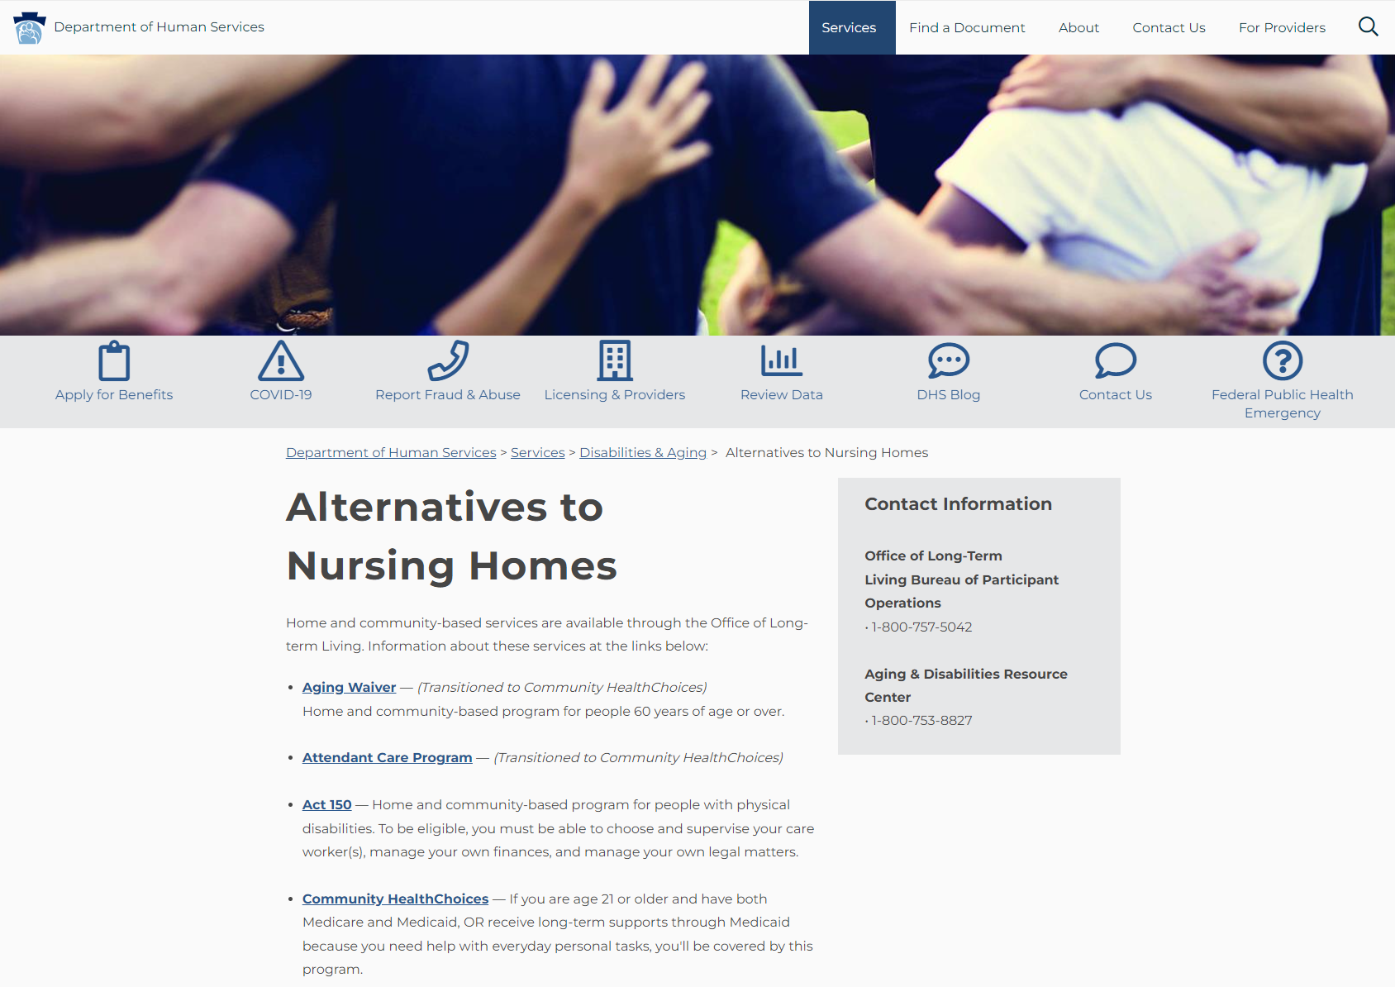

Employment and Employment-Related Services Bulletin
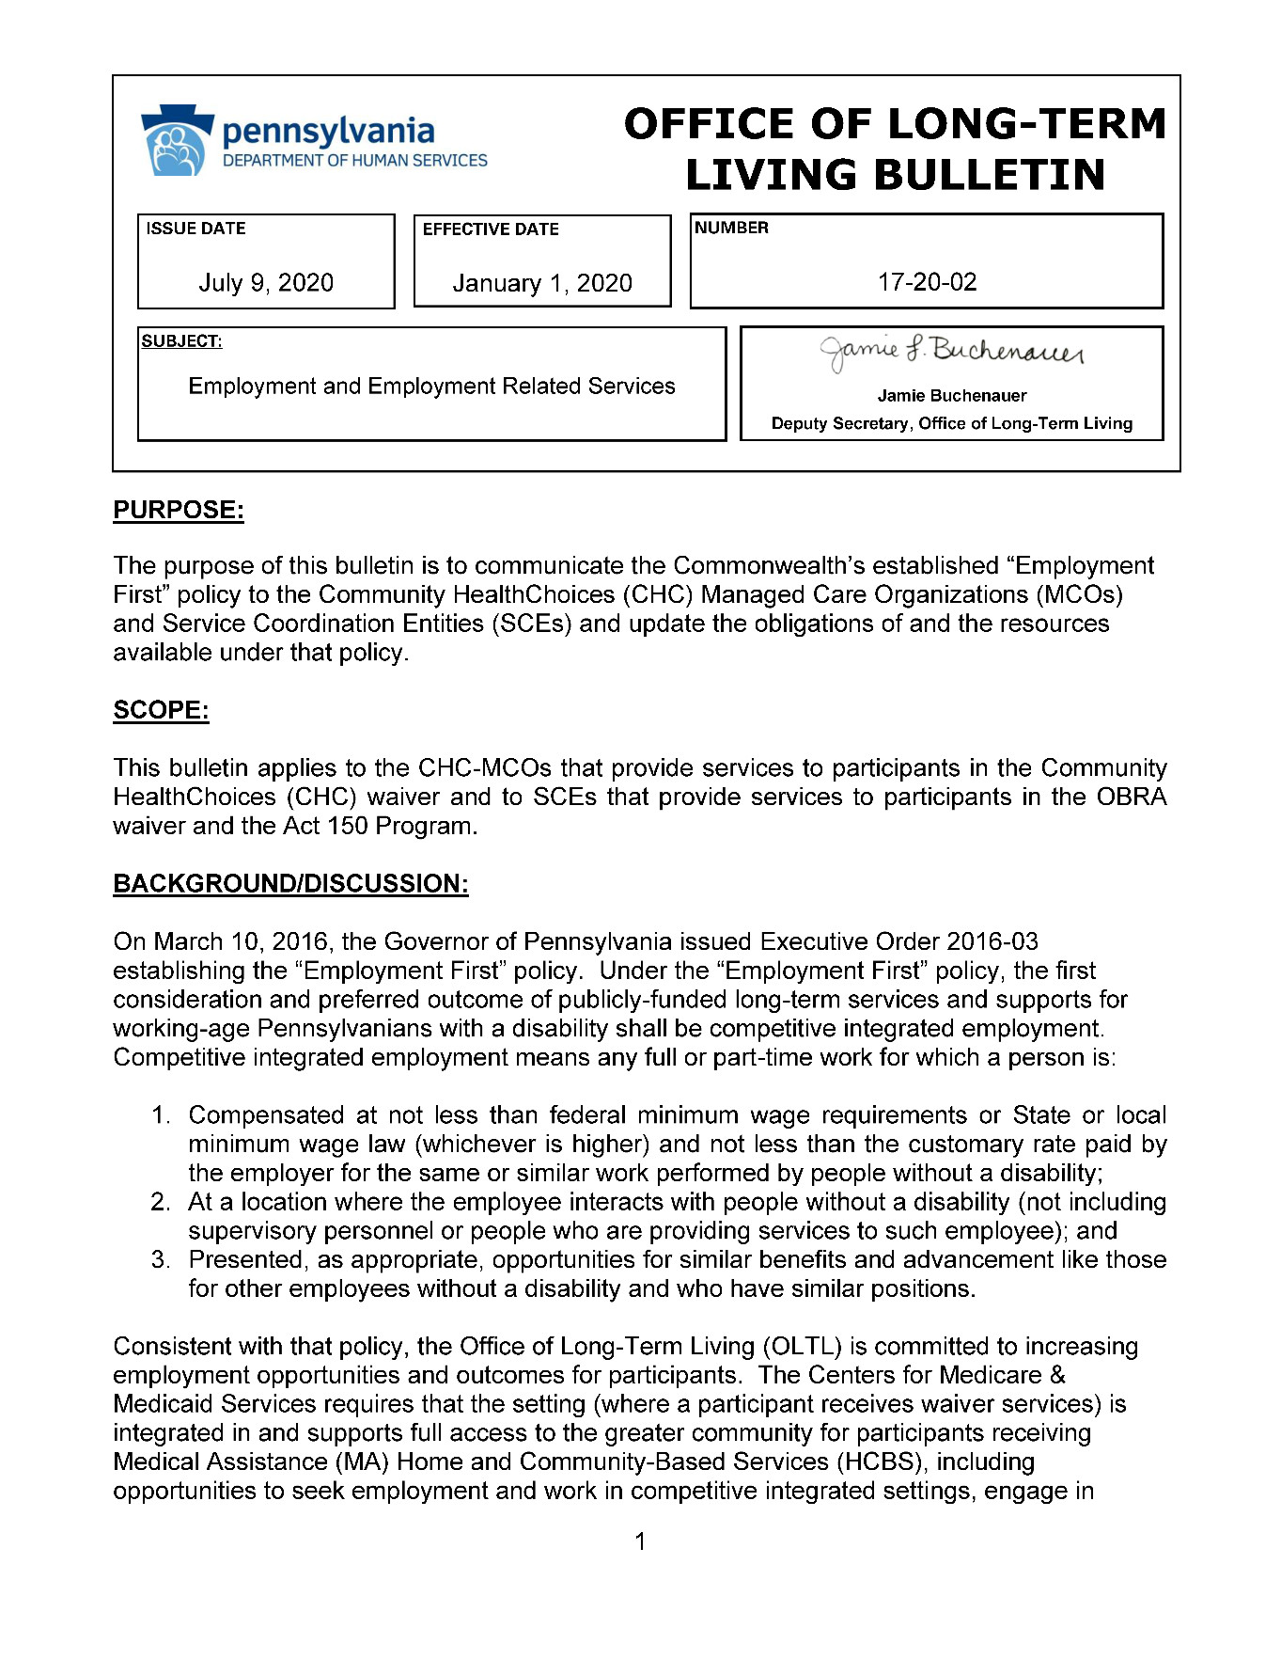
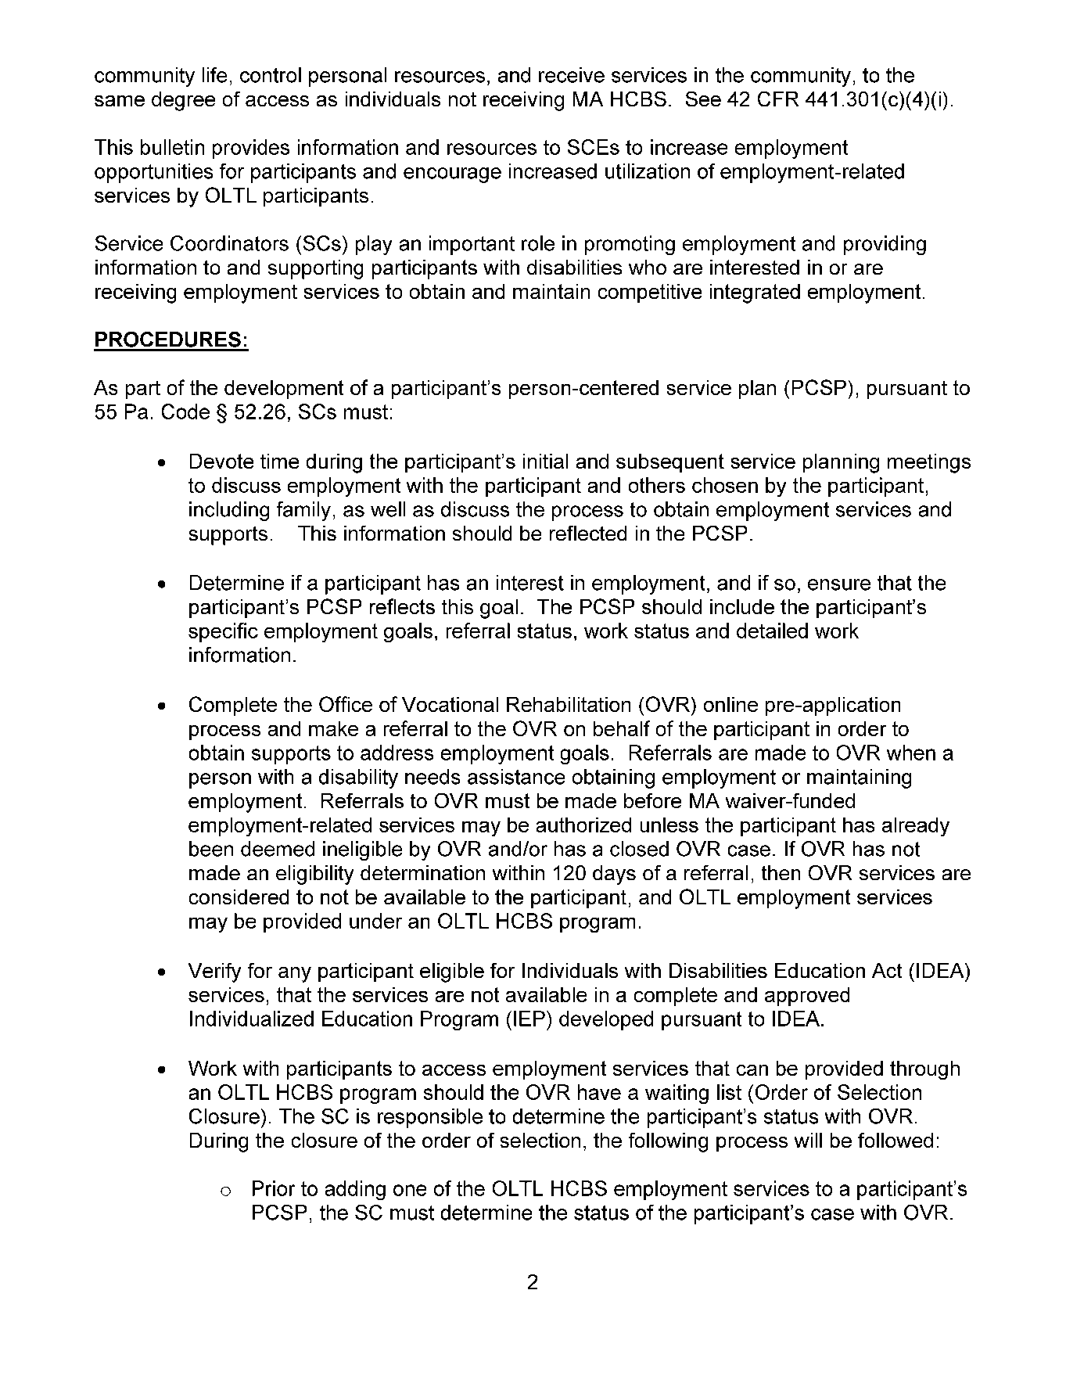

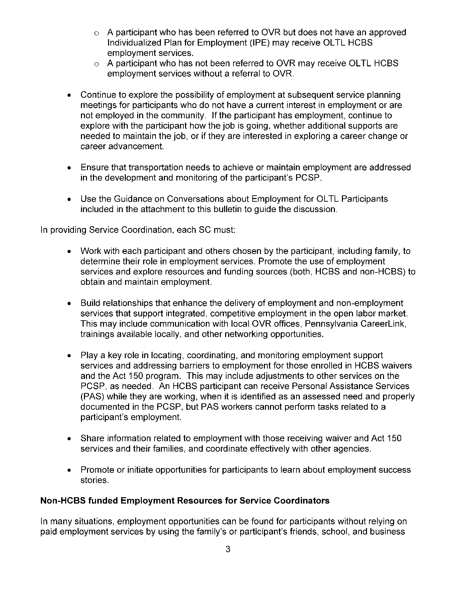

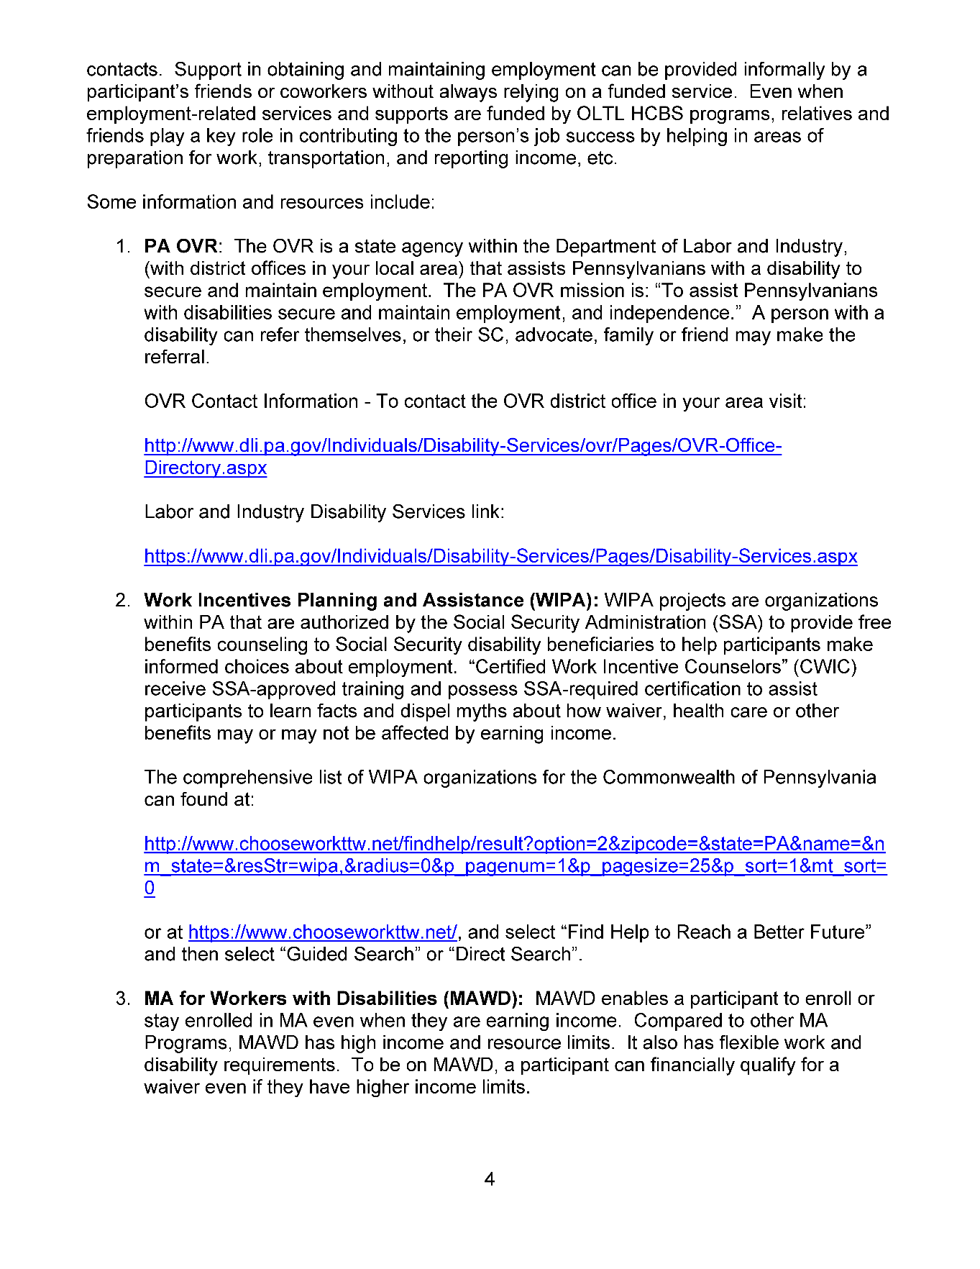

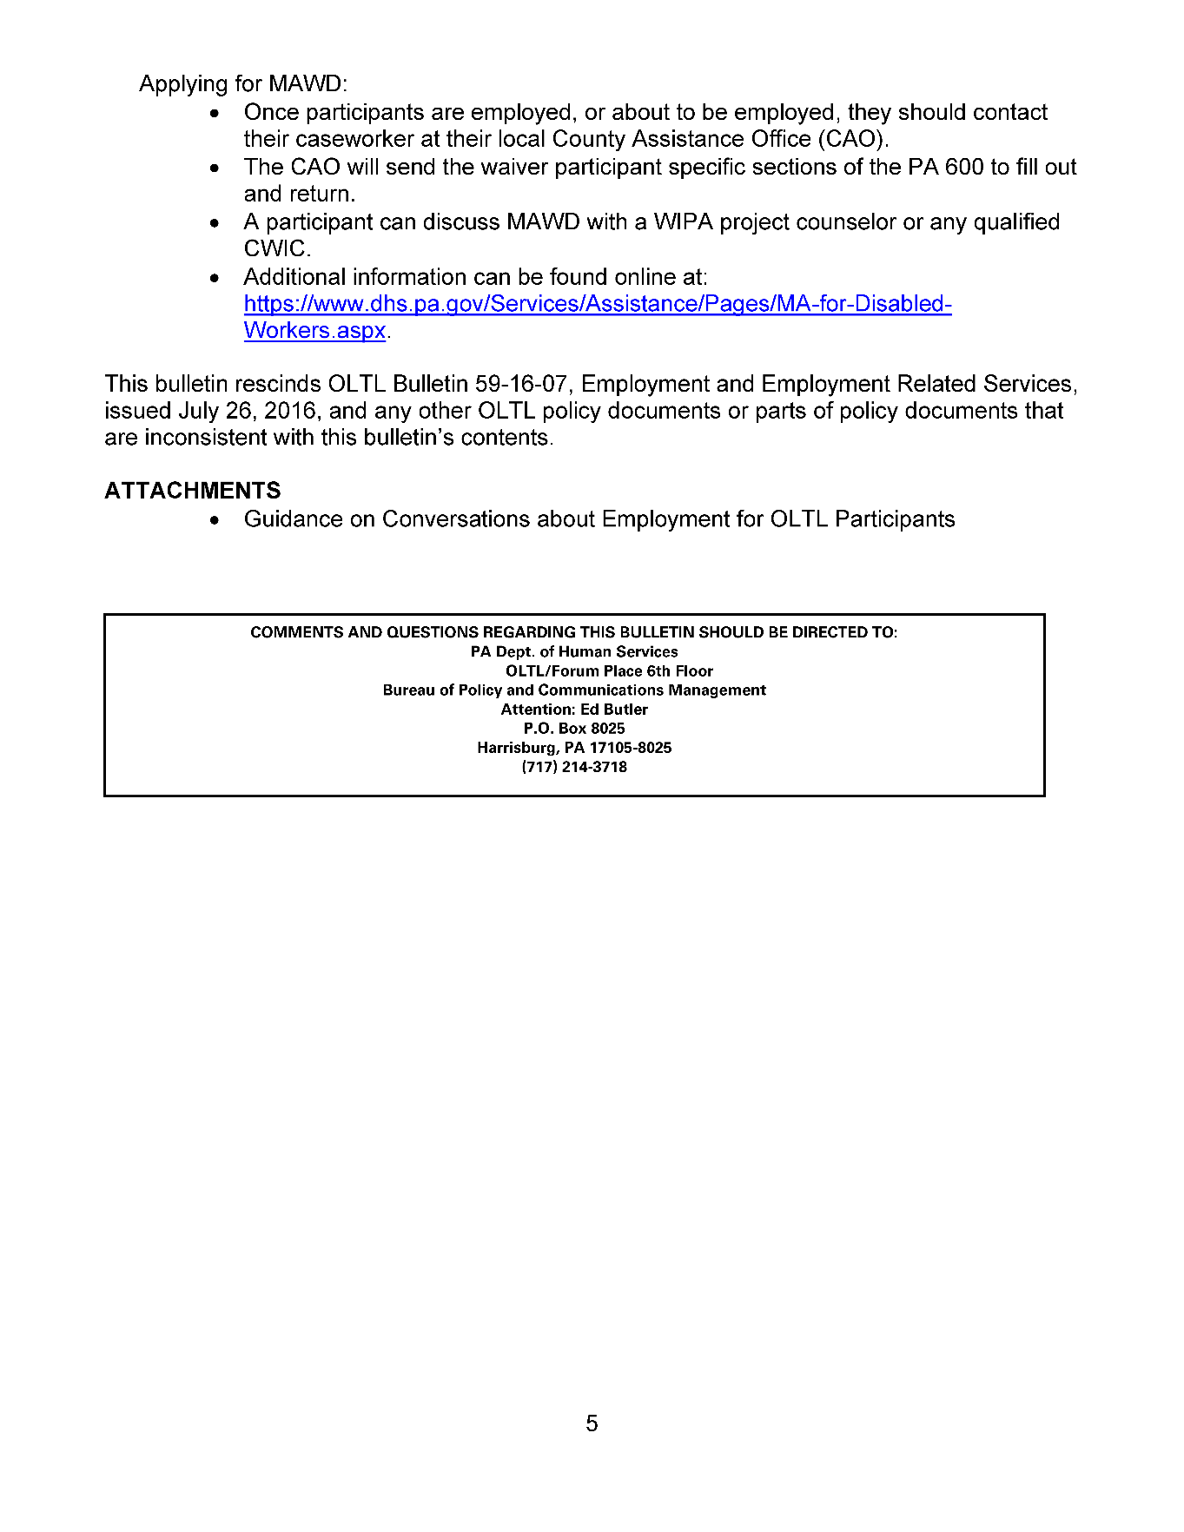

Guidance on Conversations about Employment for OLTL Participants
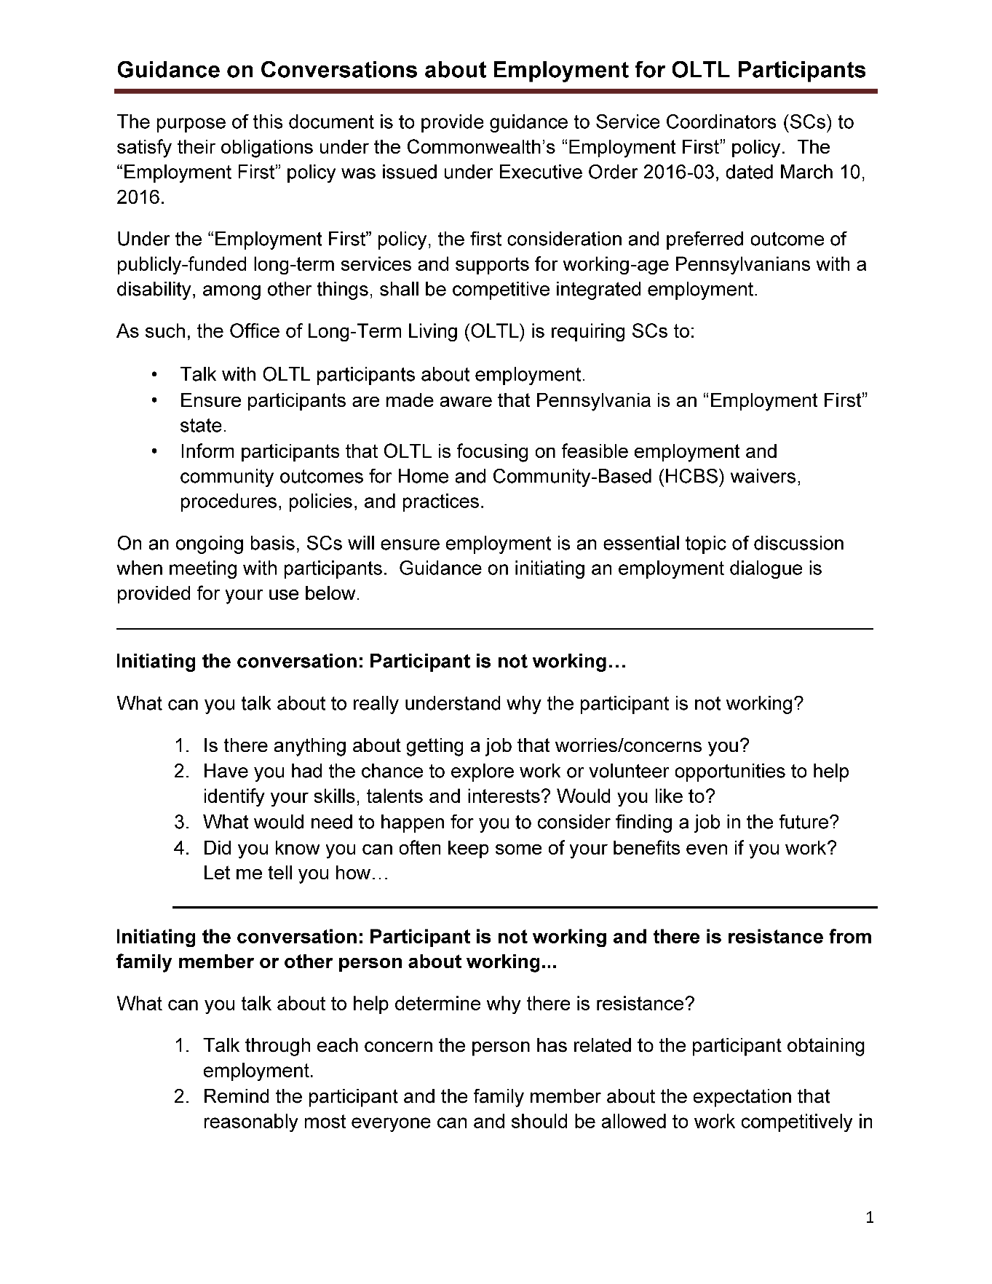
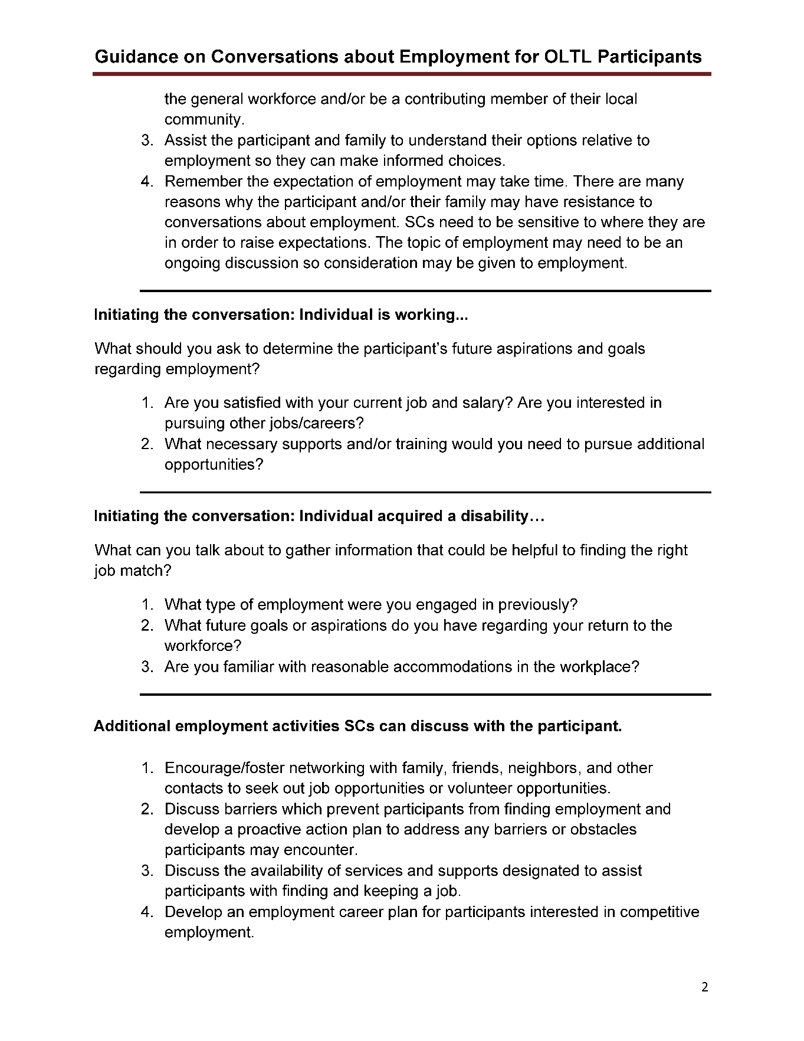

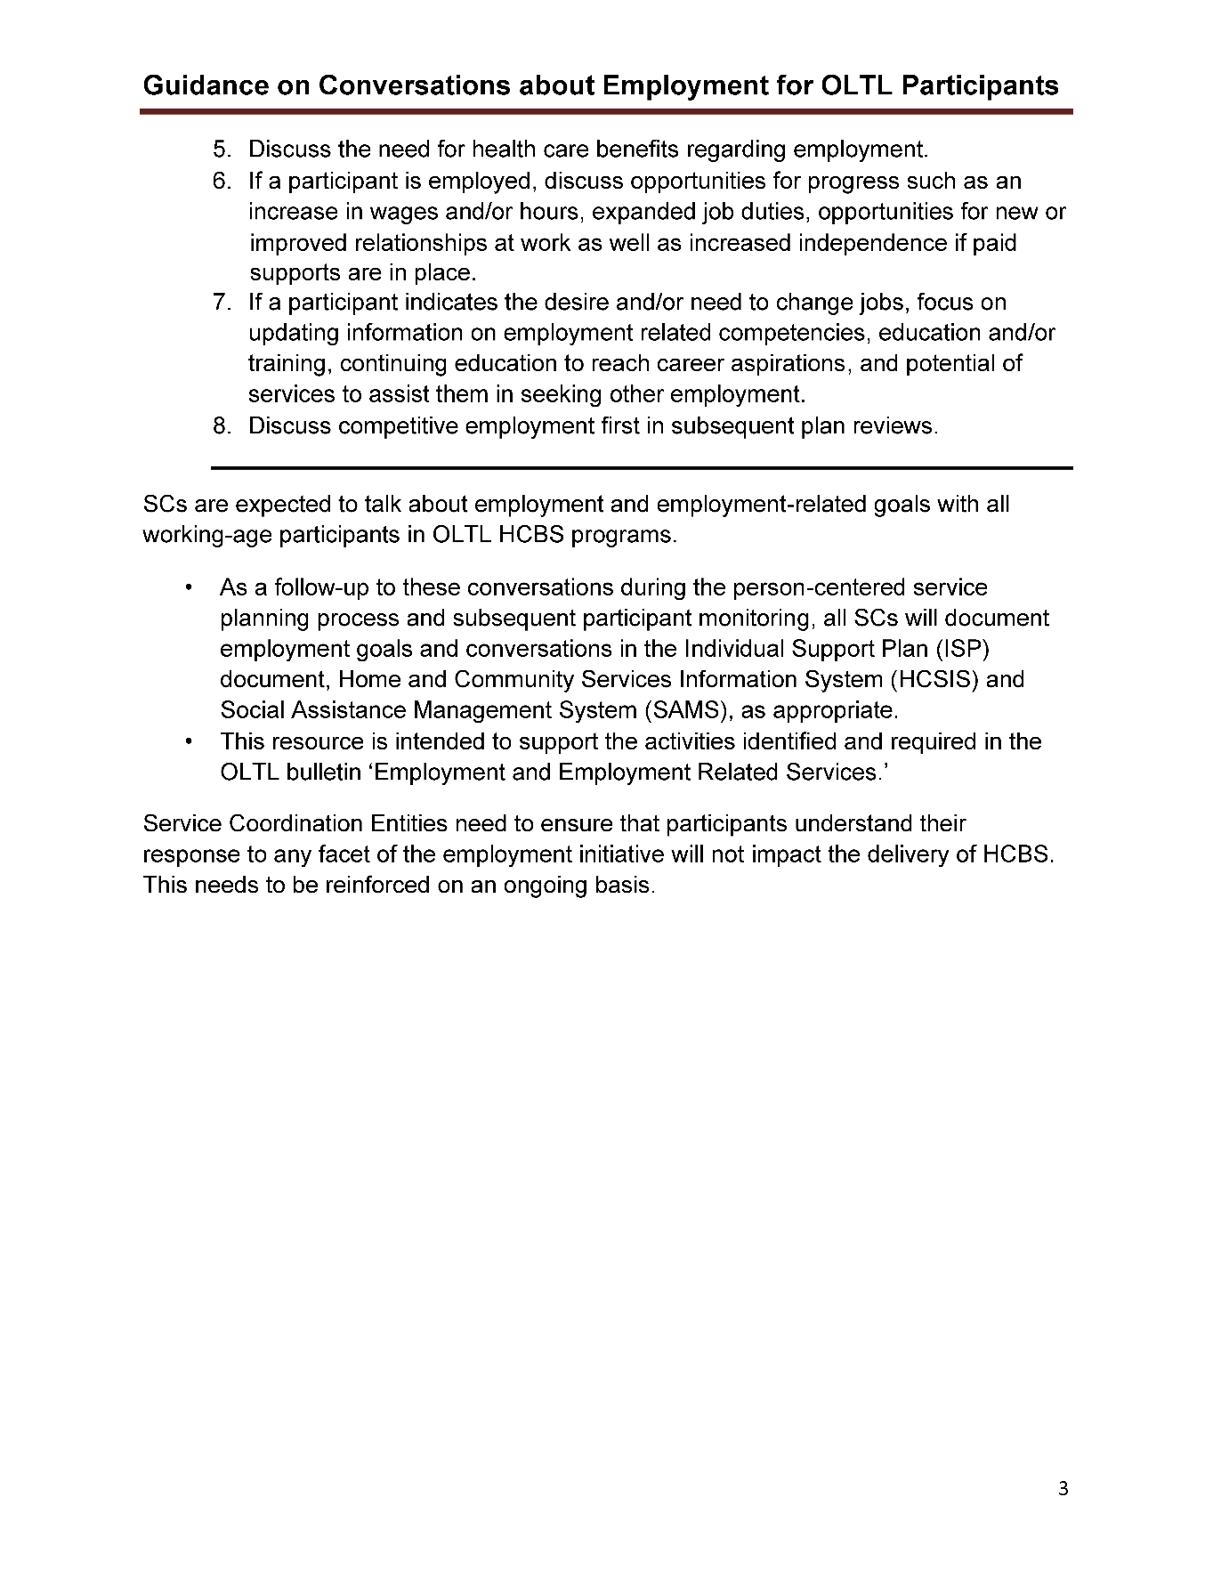

Instructions for Completing the OVR Referral
Thank you for your interest in Pennsylvania Office of Vocational Rehabilitation (OVR) services. OVR’s mission is to assist Pennsylvanians with disabilities to secure and maintain employment and independence. You can initiate a referral for OVR services via the Pennsylvania CareerLink (PA CareerLink) website using the instructions below.
Go to PA CareerLink (www.pacareerlink.pa.gov)
- Proceed with one of the following:
If you are already registered with PA CareerLink:
- Activate the “Sign In” link near the top right corner of the screen. Enter your Keystone ID and Password and Press/click the blue “Sign In” button. Select “Career Services” link in the blue menu bar at the top of the screen. Then choose “Programs and Services” link in the dropdown.
If you are a new PA CareerLink user:
- If you do not have an email account, you will need to create an account to Register.
- Activate the “Register as a New User” button near the top right corner of the screen. Select the Link “Individual Seeking OVR Services”. Complete the online registration process by following the on-screen instructions. Once you reach the Registration Confirmation page, press the “Request Staff-Assisted Service” button in the middle of the page.
- On the Request Services page, select one of two options for OVR services:
“Office of Vocational Rehabilitation – Bureau of Vocational Rehabilitation Services” OR “Office of Vocational Rehabilitation – Bureau of Blindness & Visual Services” and select whether you are or not interested in employment.

- Press the “Request Services” button near the bottom right corner of the screen. A pop-up notification will appear providing an explanation of OVR’s mission and basic eligibility criteria. Choose “YES” or “NO” to the statement: “I WANT TO WORK AND HAVE A DISABILITY THAT CURRENTLY CREATES DIFFICULTIES FOR ME IN TERMS OF GETTING, KEEPING, OR ADVANCING IN EMPLOYMENT”.
- Choosing “YES” and pressing the “Continue” button will take you to the OVR Referral Form page.
- Choosing “NO” and pressing the “Continue” button will return you to the previous page.
- On the OVR Referral Form page, complete the required questions.
- When all questions are complete, Press the “Submit Referral” button near the bottom right corner of the screen, which will send your completed referral to the OVR District Office that covers your county of residence. A notice will appear with the local District Office contact information and the following message: “A district office staff member will be contacting you within the next 10 days to start your application for vocational rehabilitation services. We look forward to speaking with you!”
OVR Office Directory
www.dli.pa.gov/Individuals/Disability-Services/ovr/Pages/OVR-Office-Directory.aspx

